FHIM Lab Notes

8/2/2010:

The reference range needs to reflect the population that is being served. For example, the hematological indices are different for somebody who lives at a higher elevation rather than sea-level.
Each laboratory is required to establish their reference range for their tests based on the test methodology and the community that they serve.

In-process tests
Employment-related conditions (i.e., a printer who is exposed to lead in the ink)

There was a cross-agency effort for DHS – surveillance.

There is a National Electronic Disease Surveillance System (at CDC) that has been actively modeling (messaging).

PHLIP Public Health Laboratory Interoperability Program
APHL – Association of Public Health Labs
FoodSafety.gov

Need a stakeholder list.

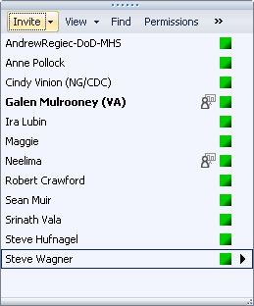

8/9/2010:

Steve Hufnagel suggested that we start with the AHIC/HITSP Lab Use cases. There are 3 of them: Order, Result, and Bio-surveillance. Steve will walk us through them next week. He also recommended that we model the use case in UML like Ioana did in the Behavioral Health model

Need to learn the C37 and the underlying IHE specification

Ann and Ira from CDC are concerned that the different kinds of labs (clinical, research, Bio-surveillance) are regulated differently.

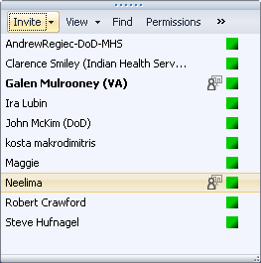

August 16, 2010

Austin Kreisler gave us an overview of HL7

The Laboratory materials are available in the 2010 Normative Edition
Orders – Composite Order (stale)
Specimen materials are also available in the 2010 Normative Edition

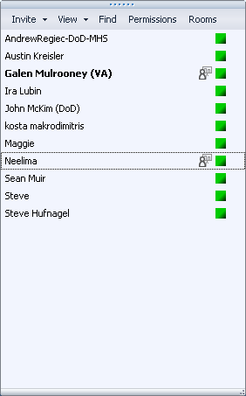

August 30, 2010

Kosta walked through the HITSP use case process
A question was raised as to whether use case modeling will be part of the FHIMS effort, and if so, what level of detail they would be. A related question was the kinds of diagrams that would be used. It is understood that in order to achieve interoperability between and among the partner agencies, the use cases and specific interactions will need to be done. The question is: at which point in the process is use case modeling performed? The answer may well vary by domain.

In a typical development project, one starts with use cases, requirements, and interactions, and then builds the information model to support them. This is the process that AHIC and HITSP followed. In re-engineering efforts, one typically first reverse-engineers the information model from the existing systems. This is the process that the VA Health Information Model (VHIM) followed. The Behavioral Health domain of the FHIM did create use cases, as they were working with a common set of assumptions about the interactions. For the FHIM Lab domain, we have existing information models from which to start, but we also have existing use cases (from HITSP), which we can also leverage.

Because HITSP and the VHIM pre-supposed clinical laboratory ordering and results, this influences the starting point for the FHIM Lab model. However, we are aware of several other categories of laboratory information that will need to be modeled. Realizing that the FHIM modeling is an iterative process, it is suggested that we create the information model to support clinical ordering and results first, and incorporate existing use cases to narrow the “subsets” of information that would be needed for each interaction. Then, in a separate iteration, tackle the other laboratory-related scenarios (e.g., Food Safety, Bio surveillance, etc.), first with use cases, then with information modeling.

Galen then described the process to establish an account on the Open Health Tools portal in order to be able to access the FHIM project artifacts. Since the FHIM is currently housed in a private space within the OHT site, each user id must be granted access rights by Galen or Sean. If you do not have access rights to the FHIM site, please contact Galen or Sean.

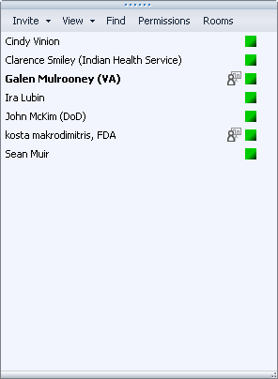

September 13, 2010

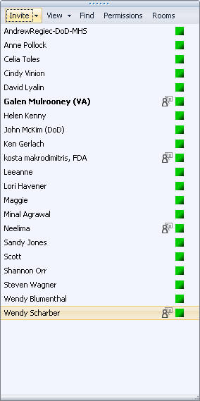

September 27, 2010

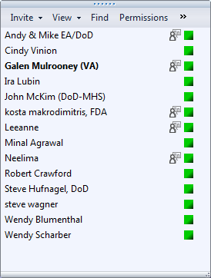

Topography = body site
Specimen = the substance received the patient (e.g., whole blood)
Sample = the substance tested (e.g., plasma)

There are two commercial packages for anatomic pathology, coPath and PathPower, which do have the ability to barcode anatomic pathology specimens

The samples may have barcodes on them that have the patient identification and the (placer collection) order number. The specimen will not have the accession number because it hasn’t been assigned yet.

October 25, 2010

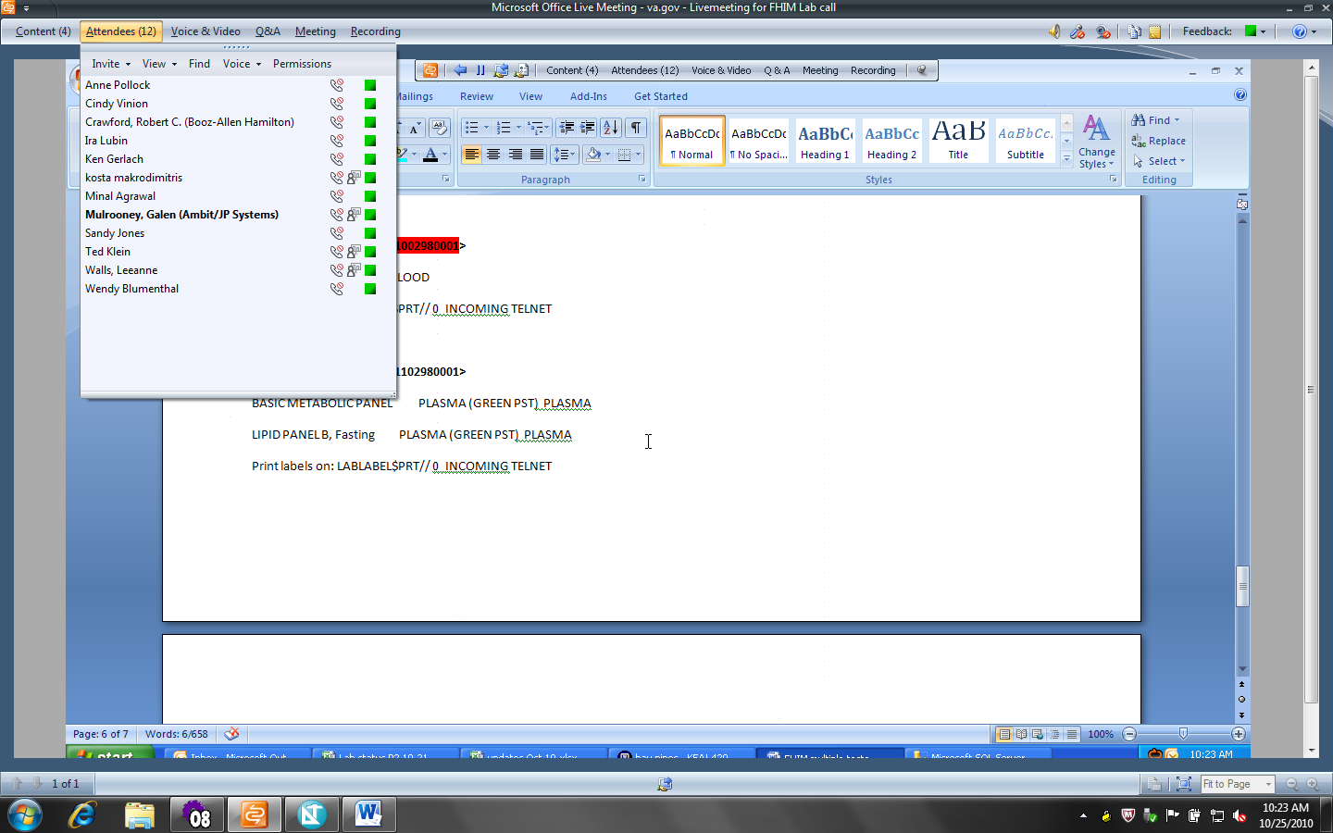
The accession is not a specimen identifier, it’s a workflow identifier.

November 8, 2010

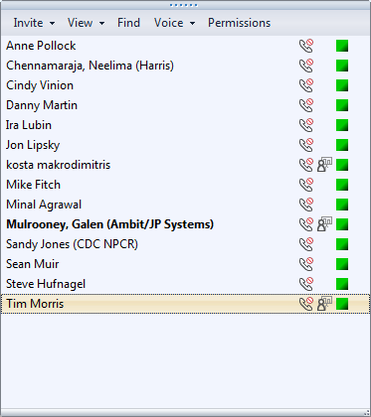

November 22, 2010

- The terms Sample and Specimen might have been modeled backwards
- Perhaps missing information on the tube or containers
- In the old days, if the same kind of tube is used (i.e., 4 tubes of blood in the same kind of tube), they’d all get the same id. But there isn’t a notion of an id for all of the blood taken at once. The ids are associated with the tube.
- Therapuetic phlebotomy – a specimen collection event happens, but no tests are done on it. But the doctor will need a confirmation that the draw happened.
- There is a distinction between collection sample and the original sample (i.e., topography)

